JAYPEE INSTITUTE OF INFORMATION TECHNOLOGY
Electronics and Communication Engineering
Electrical Science-1 (15B11EC111)
Tutorial Sheet: 5

Q1. [CO2] Find the voltage across 2Ω resistor in fig. 1 by using Superposition theorem.
Ans.(-3.41 volt)
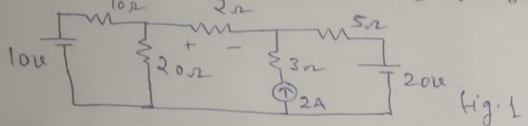
Q2. [CO1] Determine the voltage across the terminal A & B in the shown fig. 2. Ans(16 V)
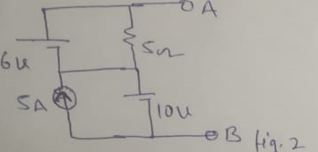

Q3.[CO2] Determine the Thevenin’s equivalent circuit across terminal A &B for the fig. 3.
Ans(V_{th}=1.85V,R_{th}=2.23K Ω)
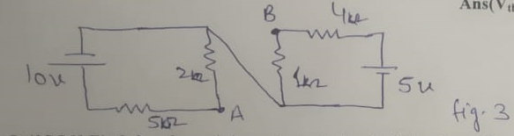

Q.4[CO2] Find th e thevenin’s equivalent circuit of the shown fig. 4.
Ans(V_{th}=0,R_{th}=3.65KΩ)
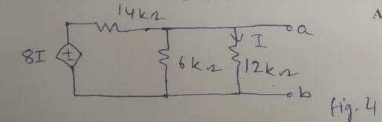
Q.5[CO2] Find V₀ in the shown fig.5 by using Norton’s theorem.
Ans(I_{sc}=1.5A,R_{th}=12/9.5,V_{o}=36/19V)
